**SQL Assignments - Set 6**

1. Produce the following output

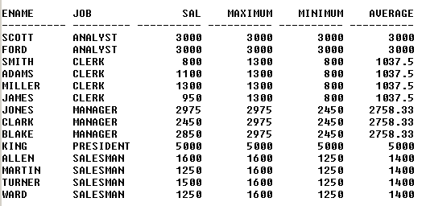

SELECT ENAME,

JOB,

SAL,

MAX(SAL) OVER(PARTITION BY JOB) "MAXIMUM",

MIN(SAL) OVER(PARTITION BY JOB) "MINIMUM",

ROUND(AVG(SAL) OVER(PARTITION BY JOB),2) "AVERAGE"

FROM EMP;

1. Produce the following output

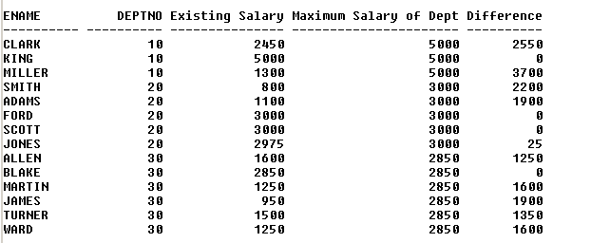

SELECT ENAME,

DEPTNO,

SAL AS "Existing Salary",

MAX(SAL) OVER(PARTITION BY DEPTNO) "MAXIMUM SALARY OF DEPT",

MAX(SAL) OVER(PARTITION BY DEPTNO) - SAL AS "Difference"

FROM EMP;

1. Display only the second highest salary employee (s) record (s) in each job type

SELECT *

FROM (SELECT *,

DENSE_RANK() OVER(PARTITION BY DEPTNO ORDER BY SAL DESC) AS SALARY_RANK

FROM EMP) EMPLOYEE_RANKING

WHERE SALARY_RANK = 2;

1. Display the record (s) of employee (s) having the oldest hiring date in their respective job type

SELECT *

FROM (SELECT *,

MIN(HIREDATE) OVER(PARTITION BY JOB) AS DATE

FROM EMP) HIREDATEE

WHERE HIREDATE = DATE;

1. Display the highest earner (s) records in each deptno

SELECT *

FROM (SELECT *,

MAX(SAL) OVER(PARTITION BY DEPTNO) AS MAXIMUM

FROM EMP) SALARY

WHERE SAL = MAXIMUM;